GitHub Actions + Vercel Deployment: Full Implementation Report

# Step 1.1: Setting up Basic Folder Structure

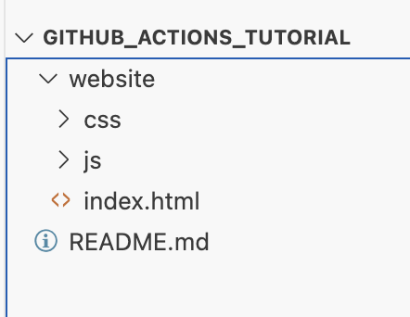

In this step, titled "Setting up Basic Folder Structure", we perform or document a key part of the GitHub Actions and Vercel deployment process. This may involve configuring the folder structure, setting up secrets, correcting workflow issues, or validating deployments. Screenshots help trace these events with visual context and confirm implementation accuracy.

# Step 2.1: Creating Vercel Token

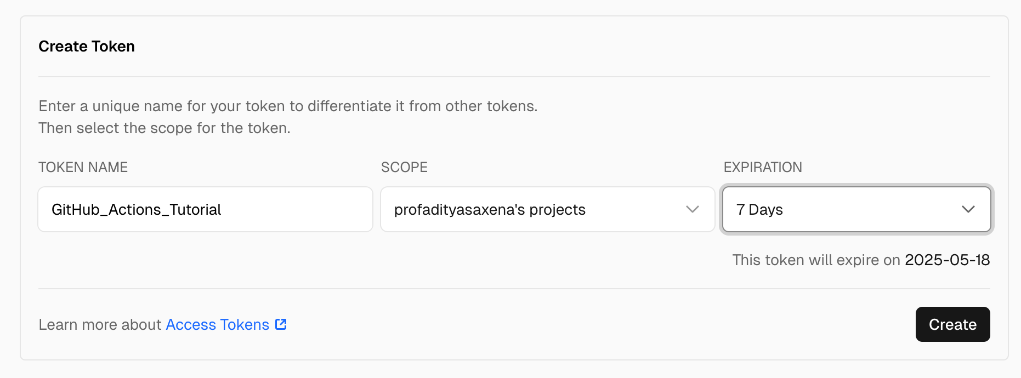

In this step, titled "Creating Vercel Token", we perform or document a key part of the GitHub Actions and Vercel deployment process. This may involve configuring the folder structure, setting up secrets, correcting workflow issues, or validating deployments. Screenshots help trace these events with visual context and confirm implementation accuracy.

# Step 3.1: Adding Secret Token to GitHub Secrets

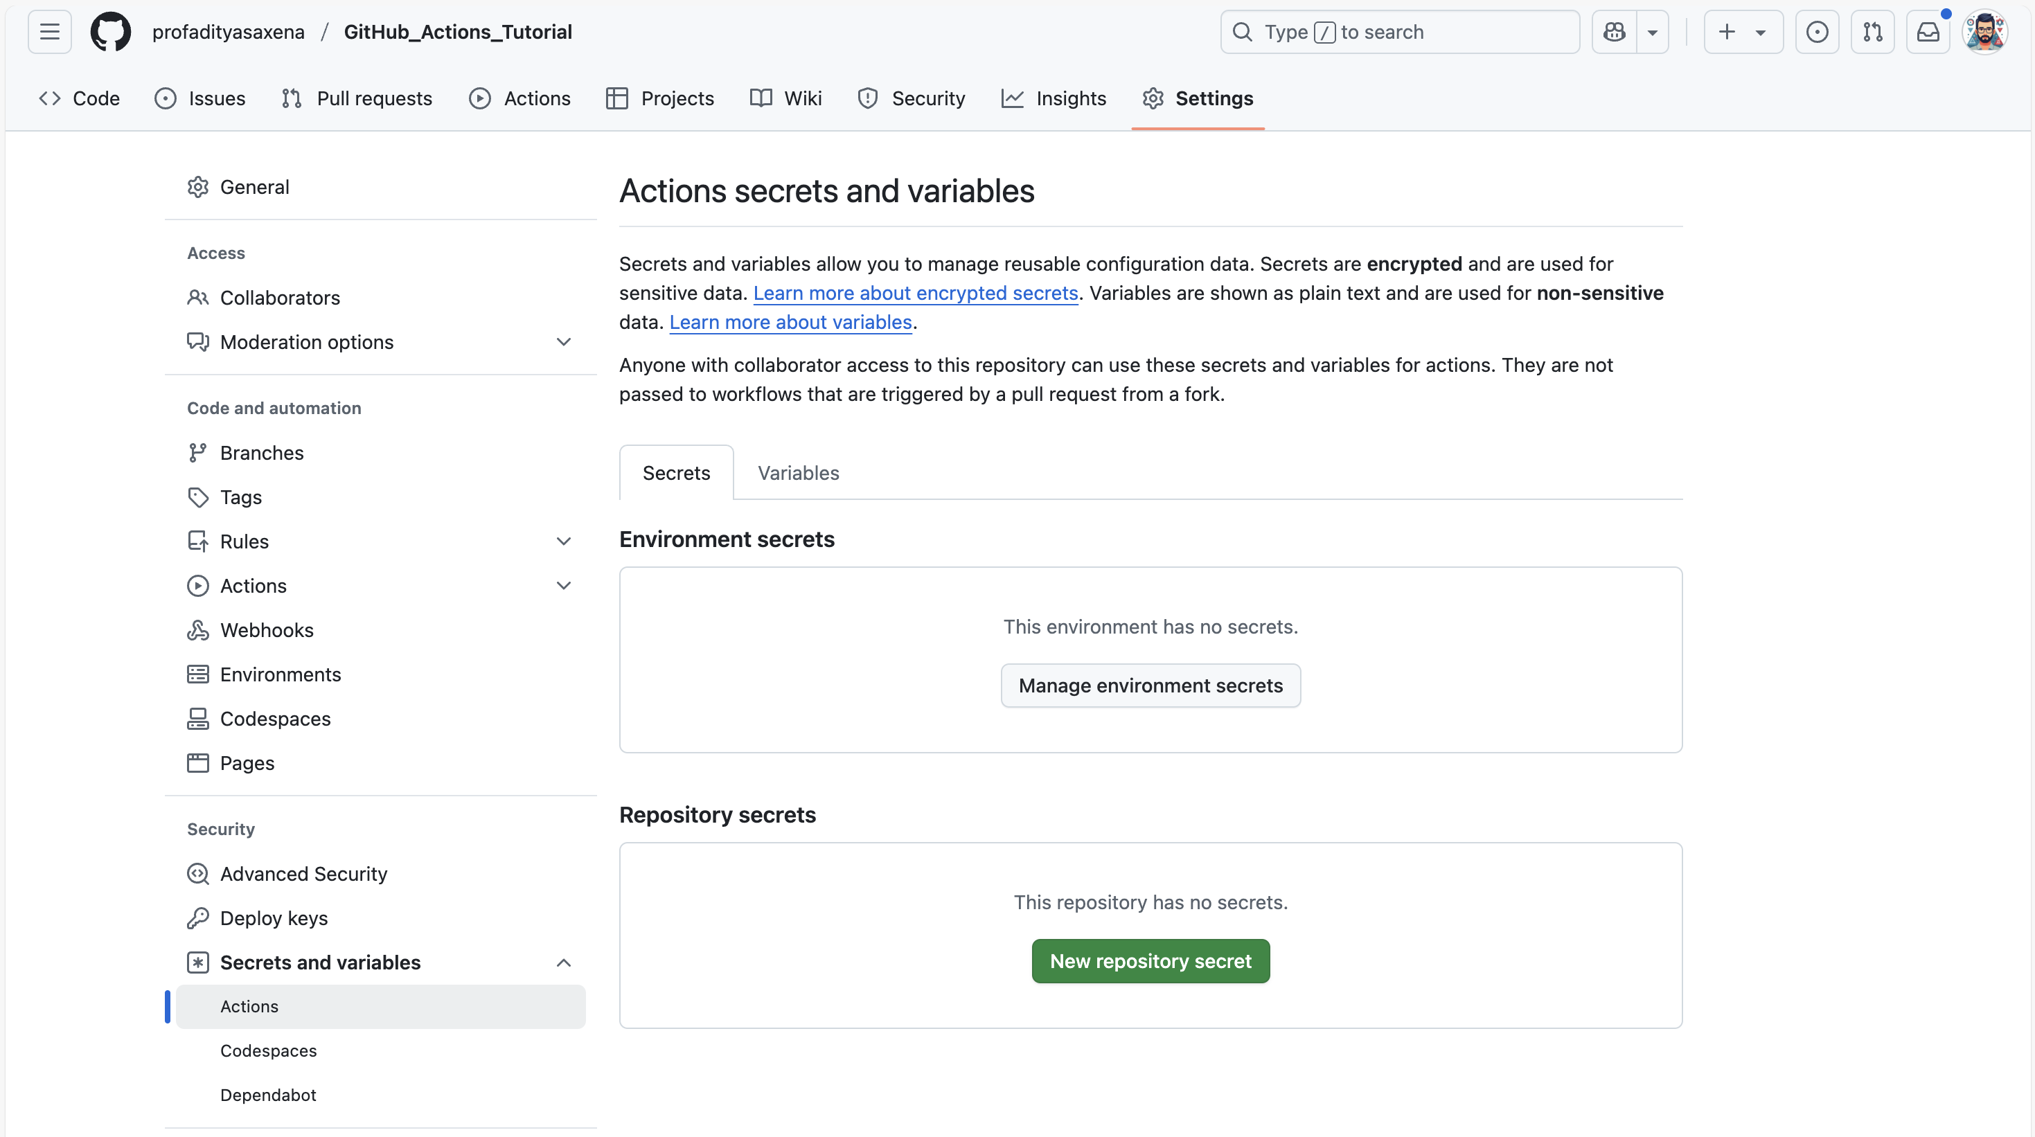

In this step, titled "Adding Secret Token to GitHub Secrets", we perform or document a key part of the GitHub Actions and Vercel deployment process. This may involve configuring the folder structure, setting up secrets, correcting workflow issues, or validating deployments. Screenshots help trace these events with visual context and confirm implementation accuracy.

# Step 3.2: Adding Secret Token to GitHub Secrets

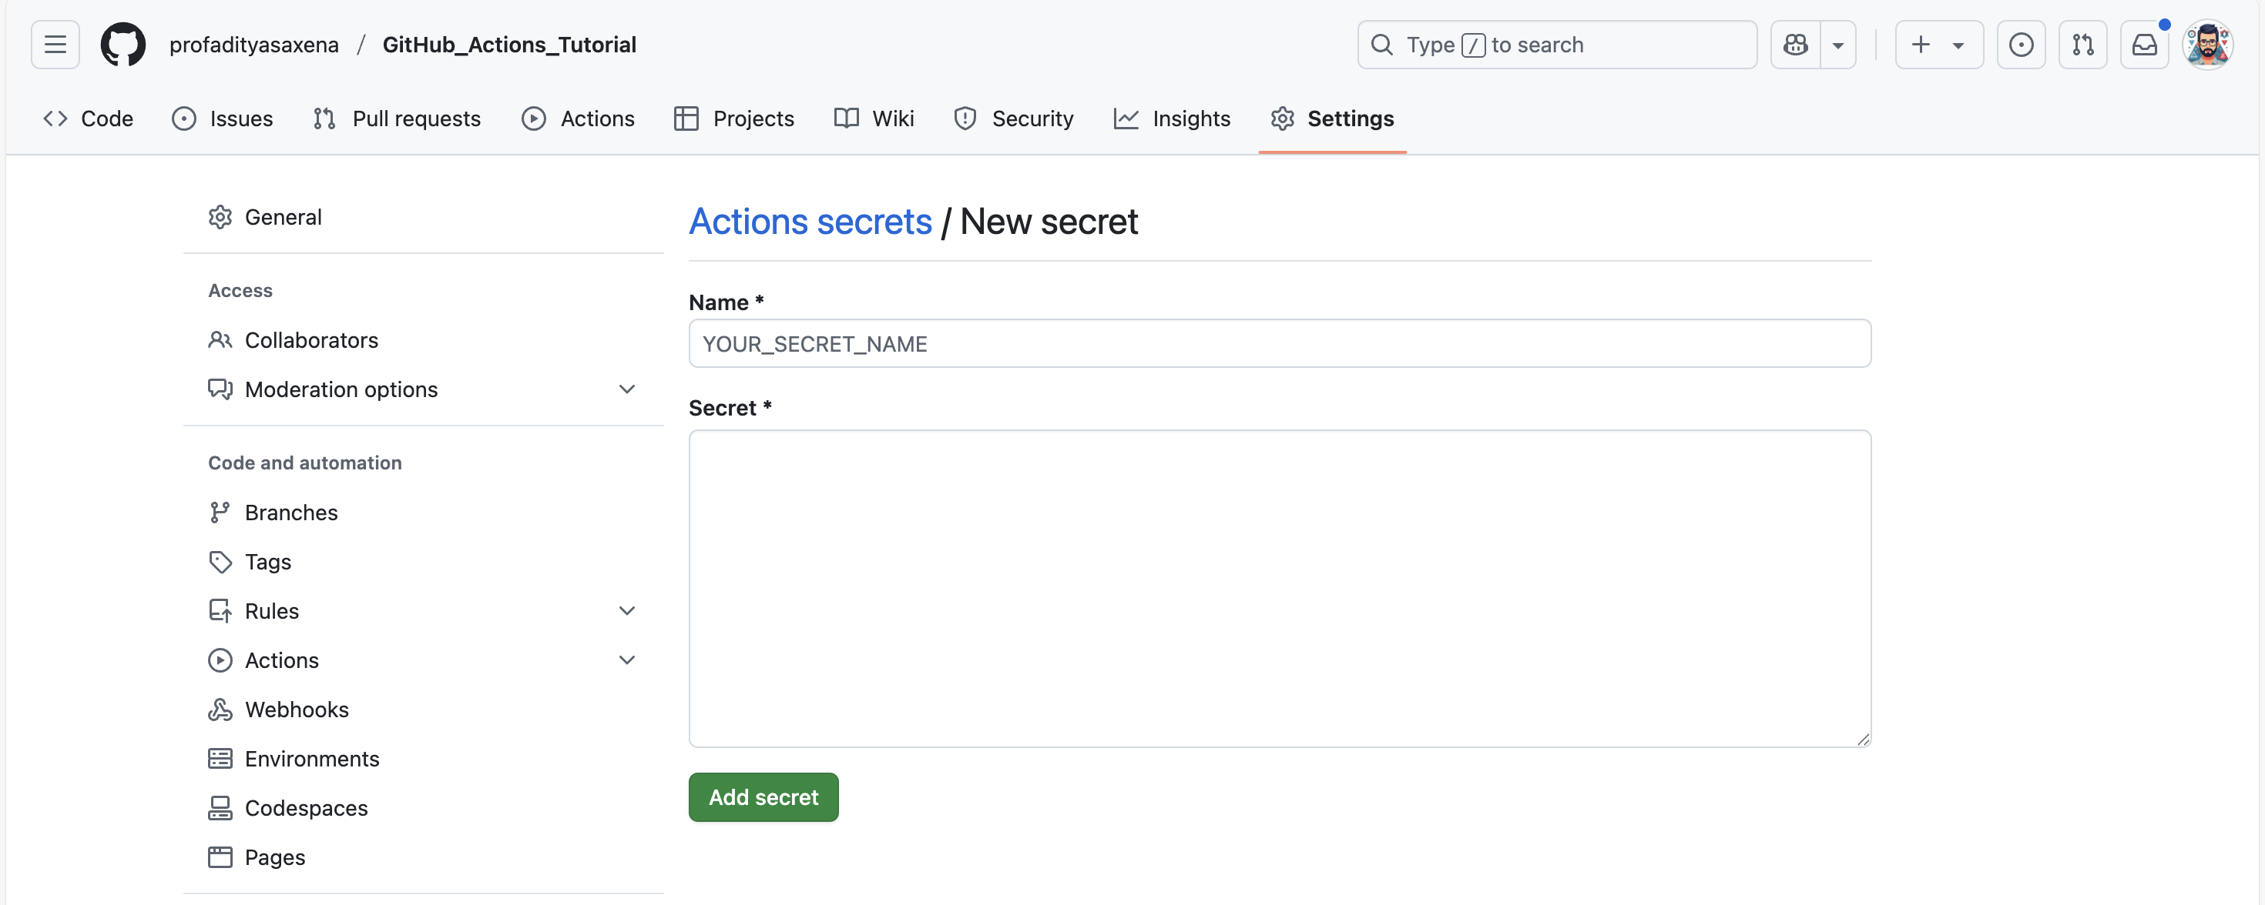

In this step, titled "Adding Secret Token to GitHub Secrets", we perform or document a key part of the GitHub Actions and Vercel deployment process. This may involve configuring the folder structure, setting up secrets, correcting workflow issues, or validating deployments. Screenshots help trace these events with visual context and confirm implementation accuracy.

# Step 3.3: Adding Secret Token to GitHub Secrets

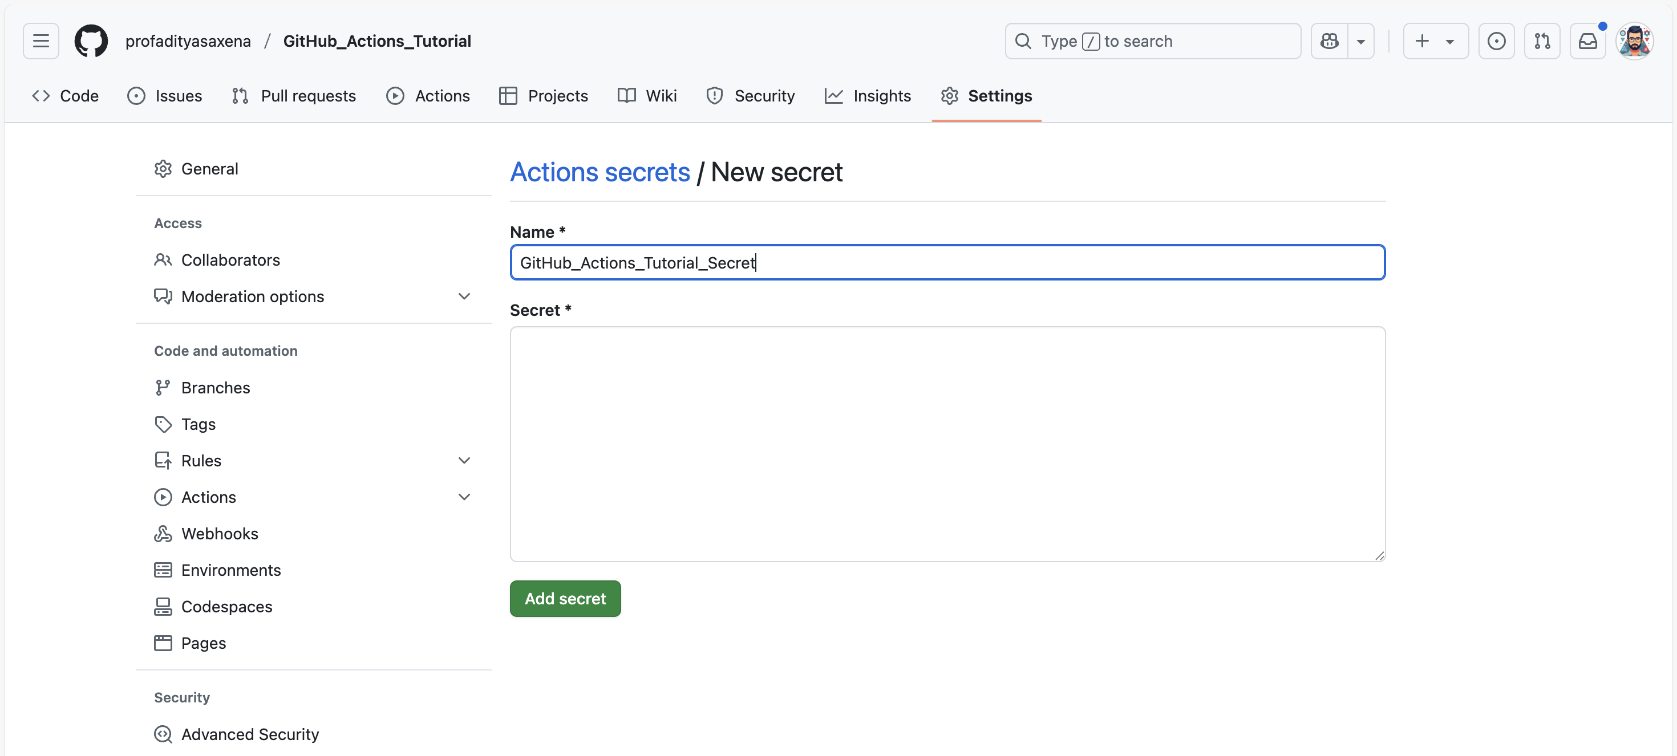

In this step, titled "Adding Secret Token to GitHub Secrets", we perform or document a key part of the GitHub Actions and Vercel deployment process. This may involve configuring the folder structure, setting up secrets, correcting workflow issues, or validating deployments. Screenshots help trace these events with visual context and confirm implementation accuracy.

# Step 3.4: Adding Secret Token to GitHub Secrets

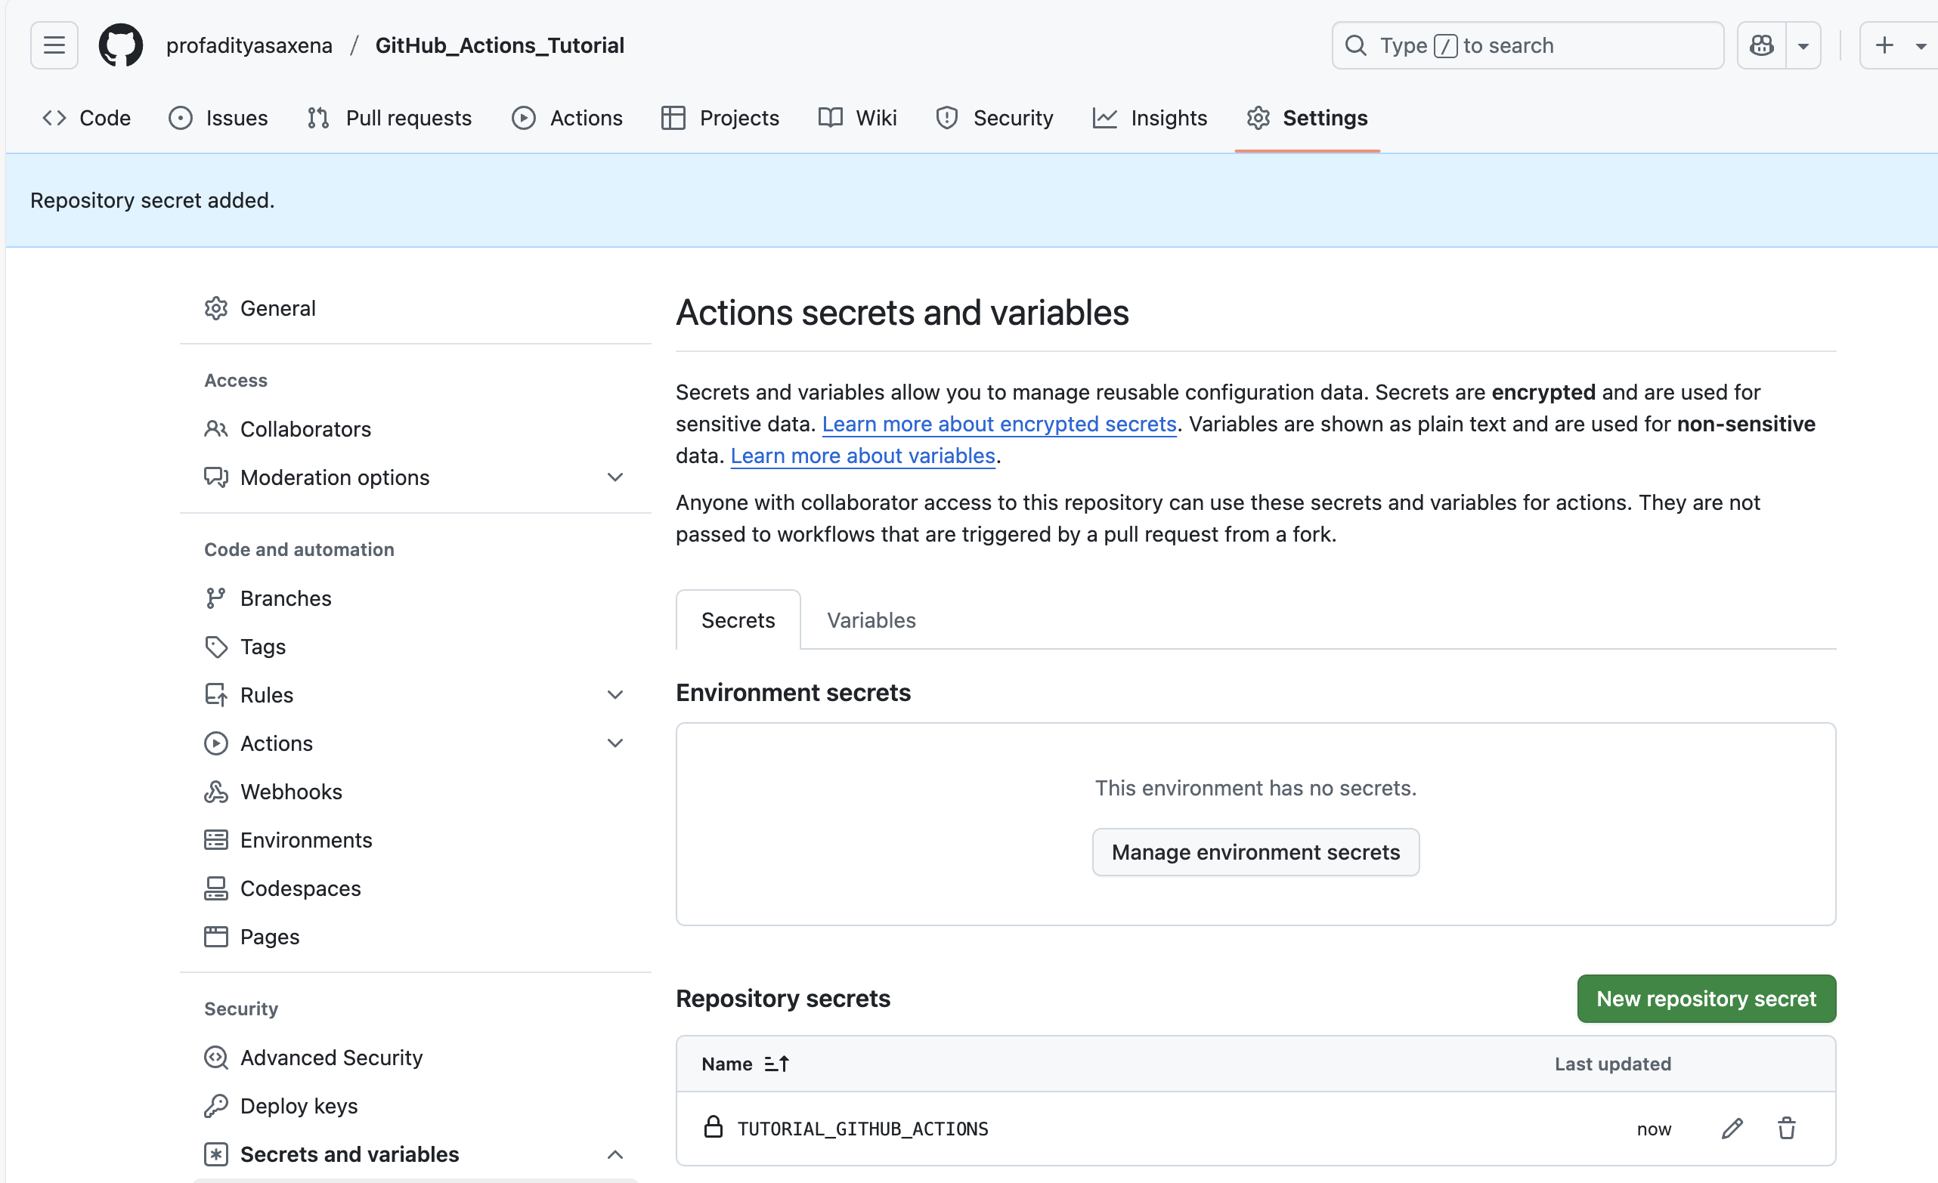

In this step, titled "Adding Secret Token to GitHub Secrets", we perform or document a key part of the GitHub Actions and Vercel deployment process. This may involve configuring the folder structure, setting up secrets, correcting workflow issues, or validating deployments. Screenshots help trace these events with visual context and confirm implementation accuracy.

# Step 4.1: Removing GitHub Connection

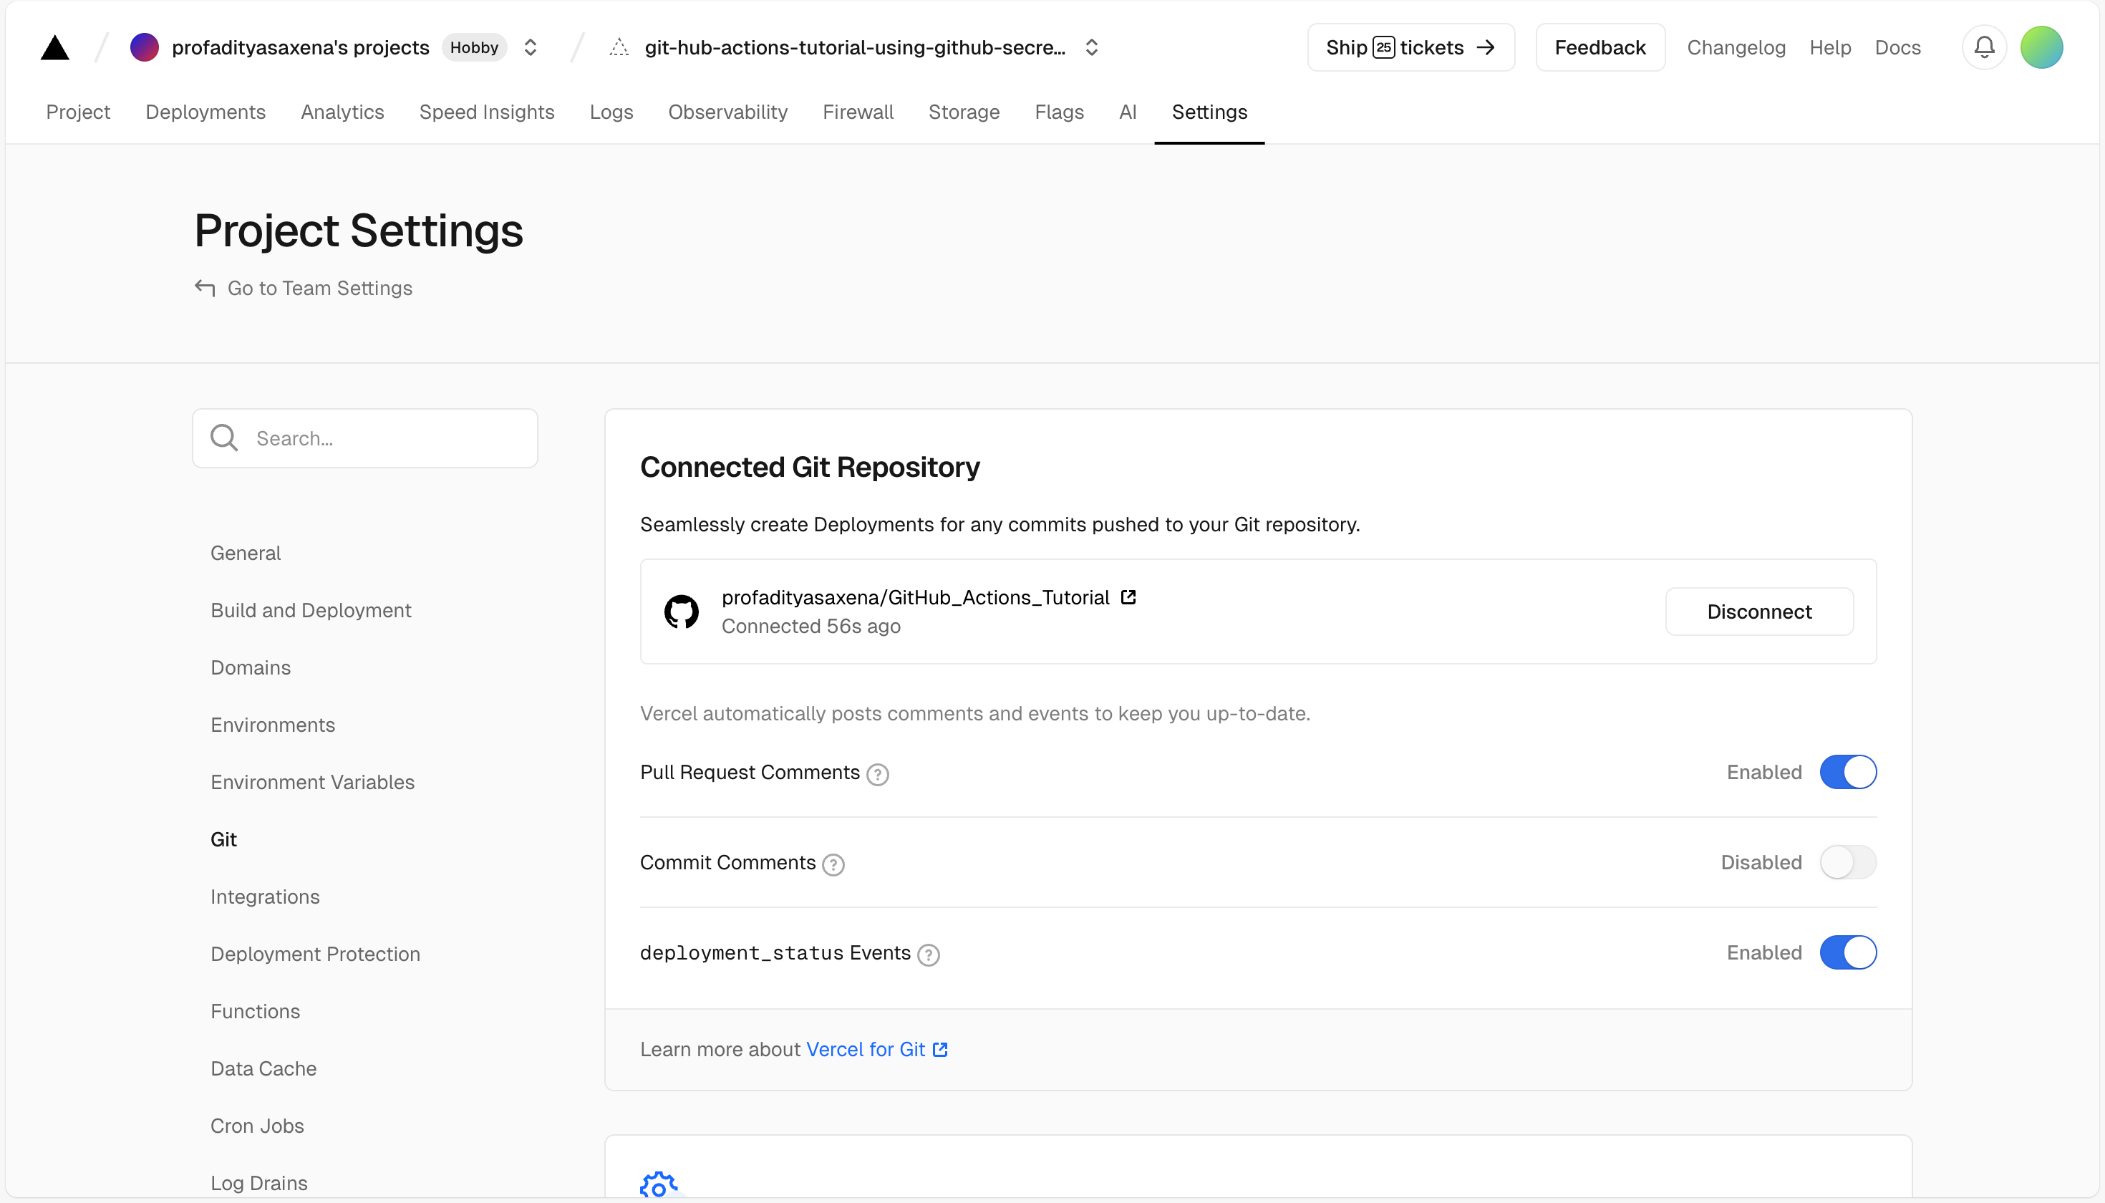

In this step, titled "Removing GitHub Connection", we perform or document a key part of the GitHub Actions and Vercel deployment process. This may involve configuring the folder structure, setting up secrets, correcting workflow issues, or validating deployments. Screenshots help trace these events with visual context and confirm implementation accuracy.

# Step 4.2: Removing GitHub Connection

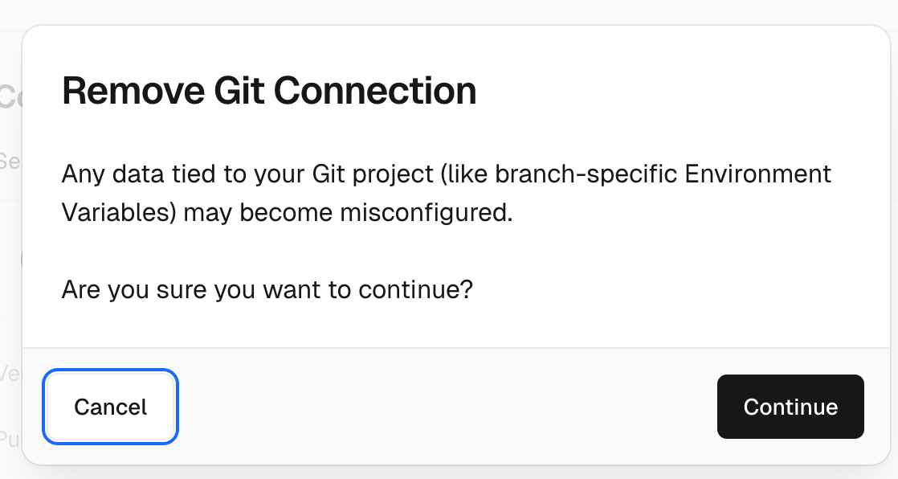

In this step, titled "Removing GitHub Connection", we perform or document a key part of the GitHub Actions and Vercel deployment process. This may involve configuring the folder structure, setting up secrets, correcting workflow issues, or validating deployments. Screenshots help trace these events with visual context and confirm implementation accuracy.

# Step 4.3: Removing GitHub Connection

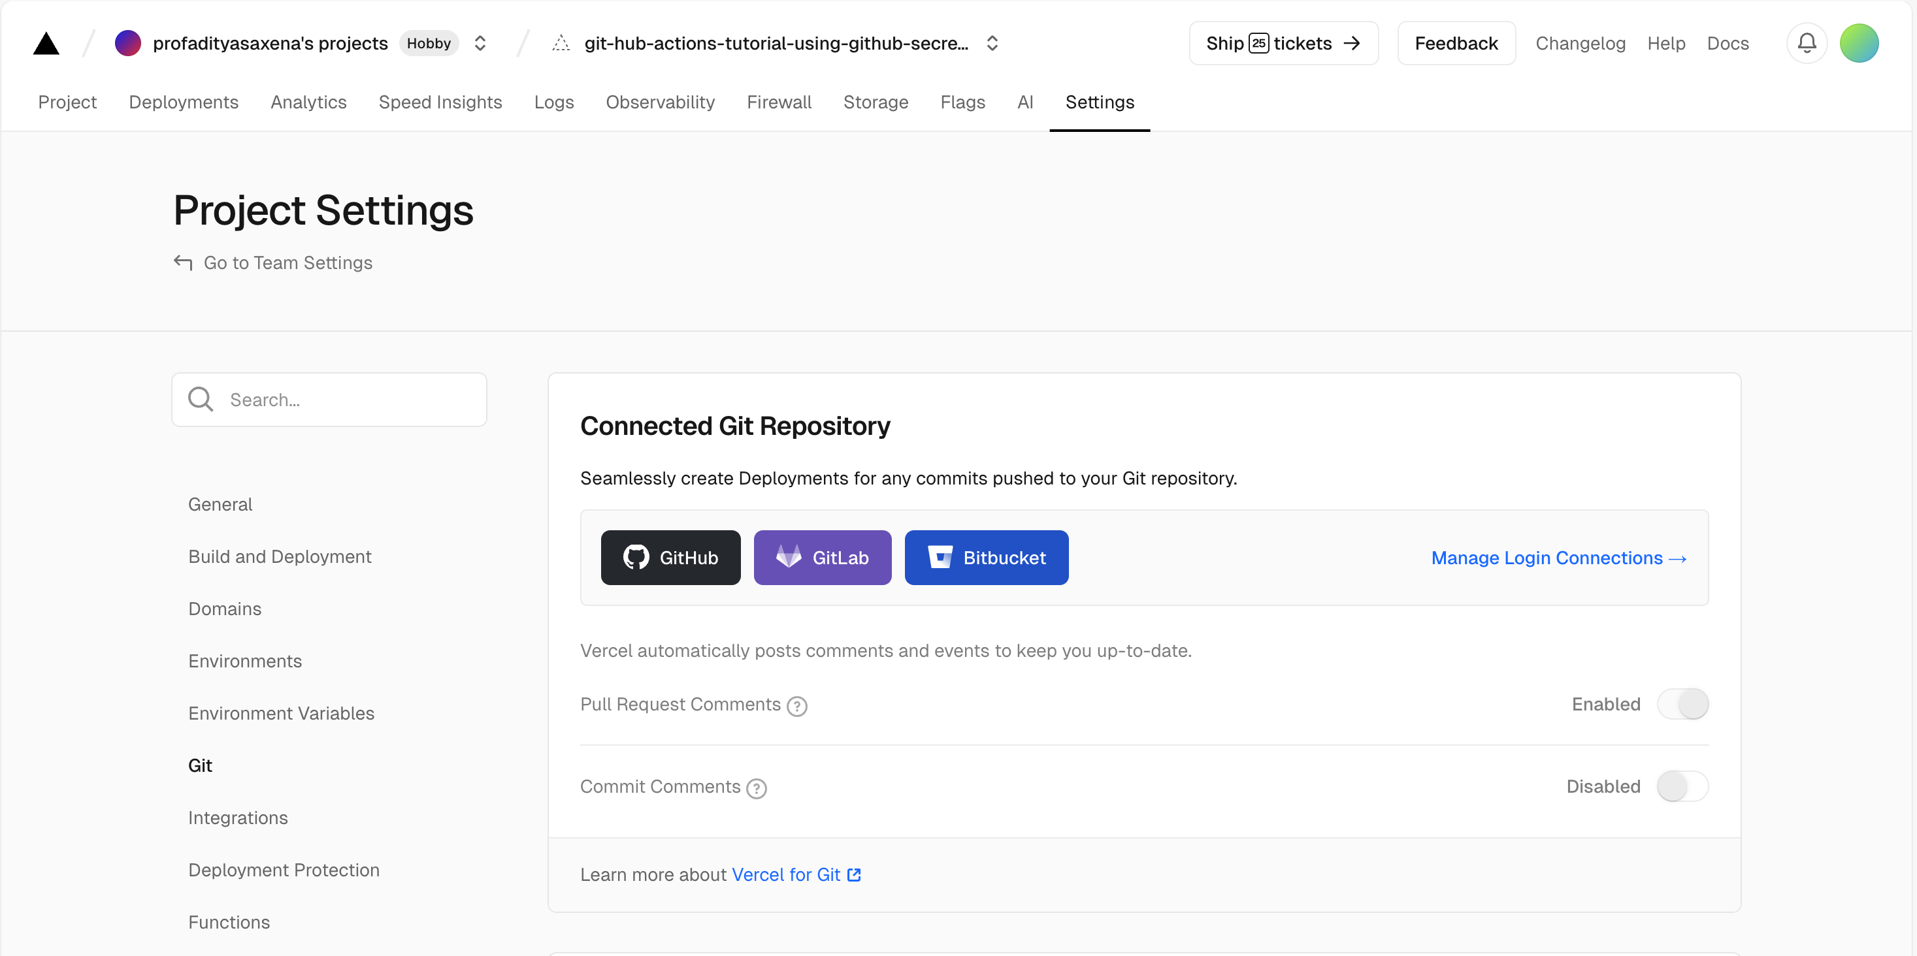

In this step, titled "Removing GitHub Connection", we perform or document a key part of the GitHub Actions and Vercel deployment process. This may involve configuring the folder structure, setting up secrets, correcting workflow issues, or validating deployments. Screenshots help trace these events with visual context and confirm implementation accuracy.

# Step 5.1: Testing Changes on Git Connected Vercel App

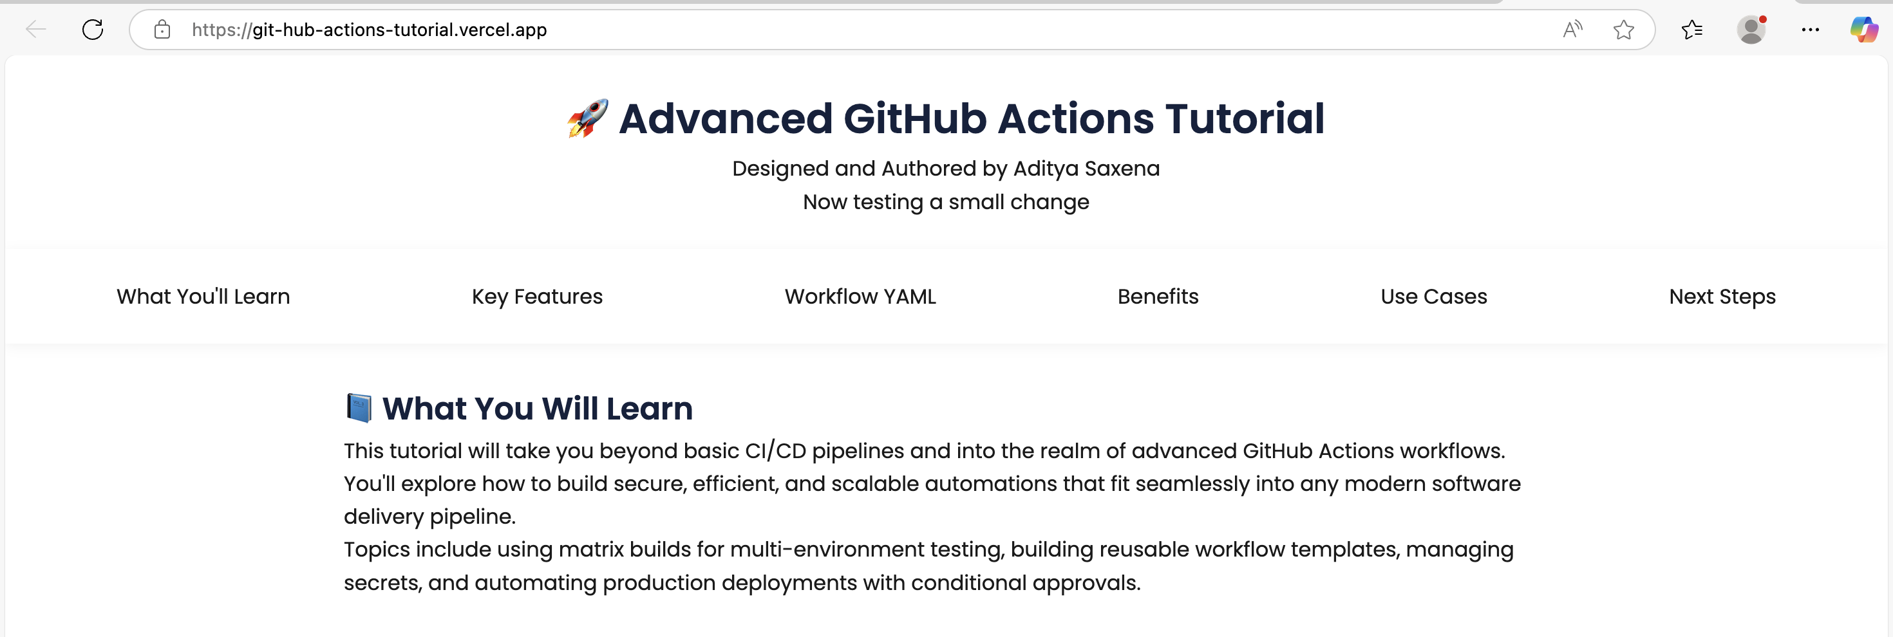

In this step, titled "Testing Changes on Git Connected Vercel App", we perform or document a key part of the GitHub Actions and Vercel deployment process. This may involve configuring the folder structure, setting up secrets, correcting workflow issues, or validating deployments. Screenshots help trace these events with visual context and confirm implementation accuracy.

# Step 5.2: Testing Changes on GitHub Actions Connected Vercel App

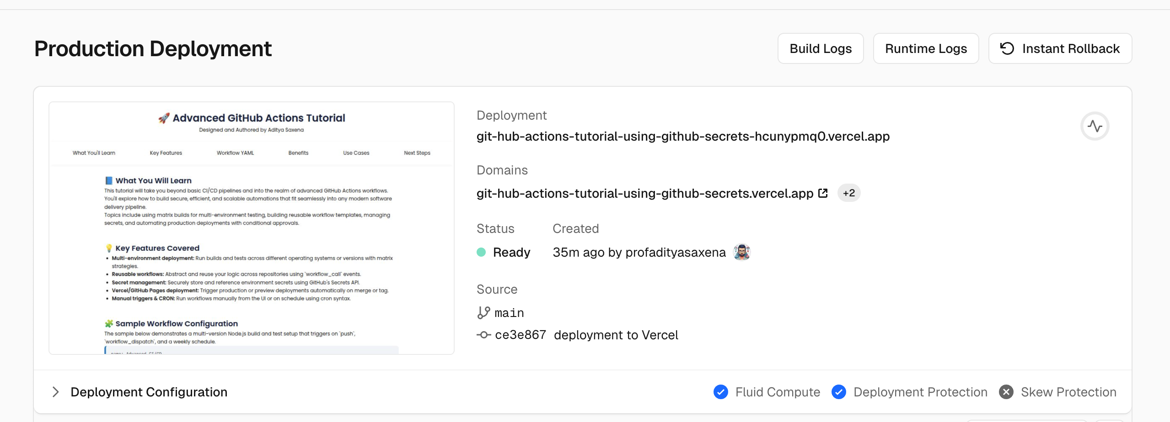

In this step, titled "Testing Changes on GitHub Actions Connected Vercel App", we perform or document a key part of the GitHub Actions and Vercel deployment process. This may involve configuring the folder structure, setting up secrets, correcting workflow issues, or validating deployments. Screenshots help trace these events with visual context and confirm implementation accuracy.

# Step 6.1: Troubleshooting

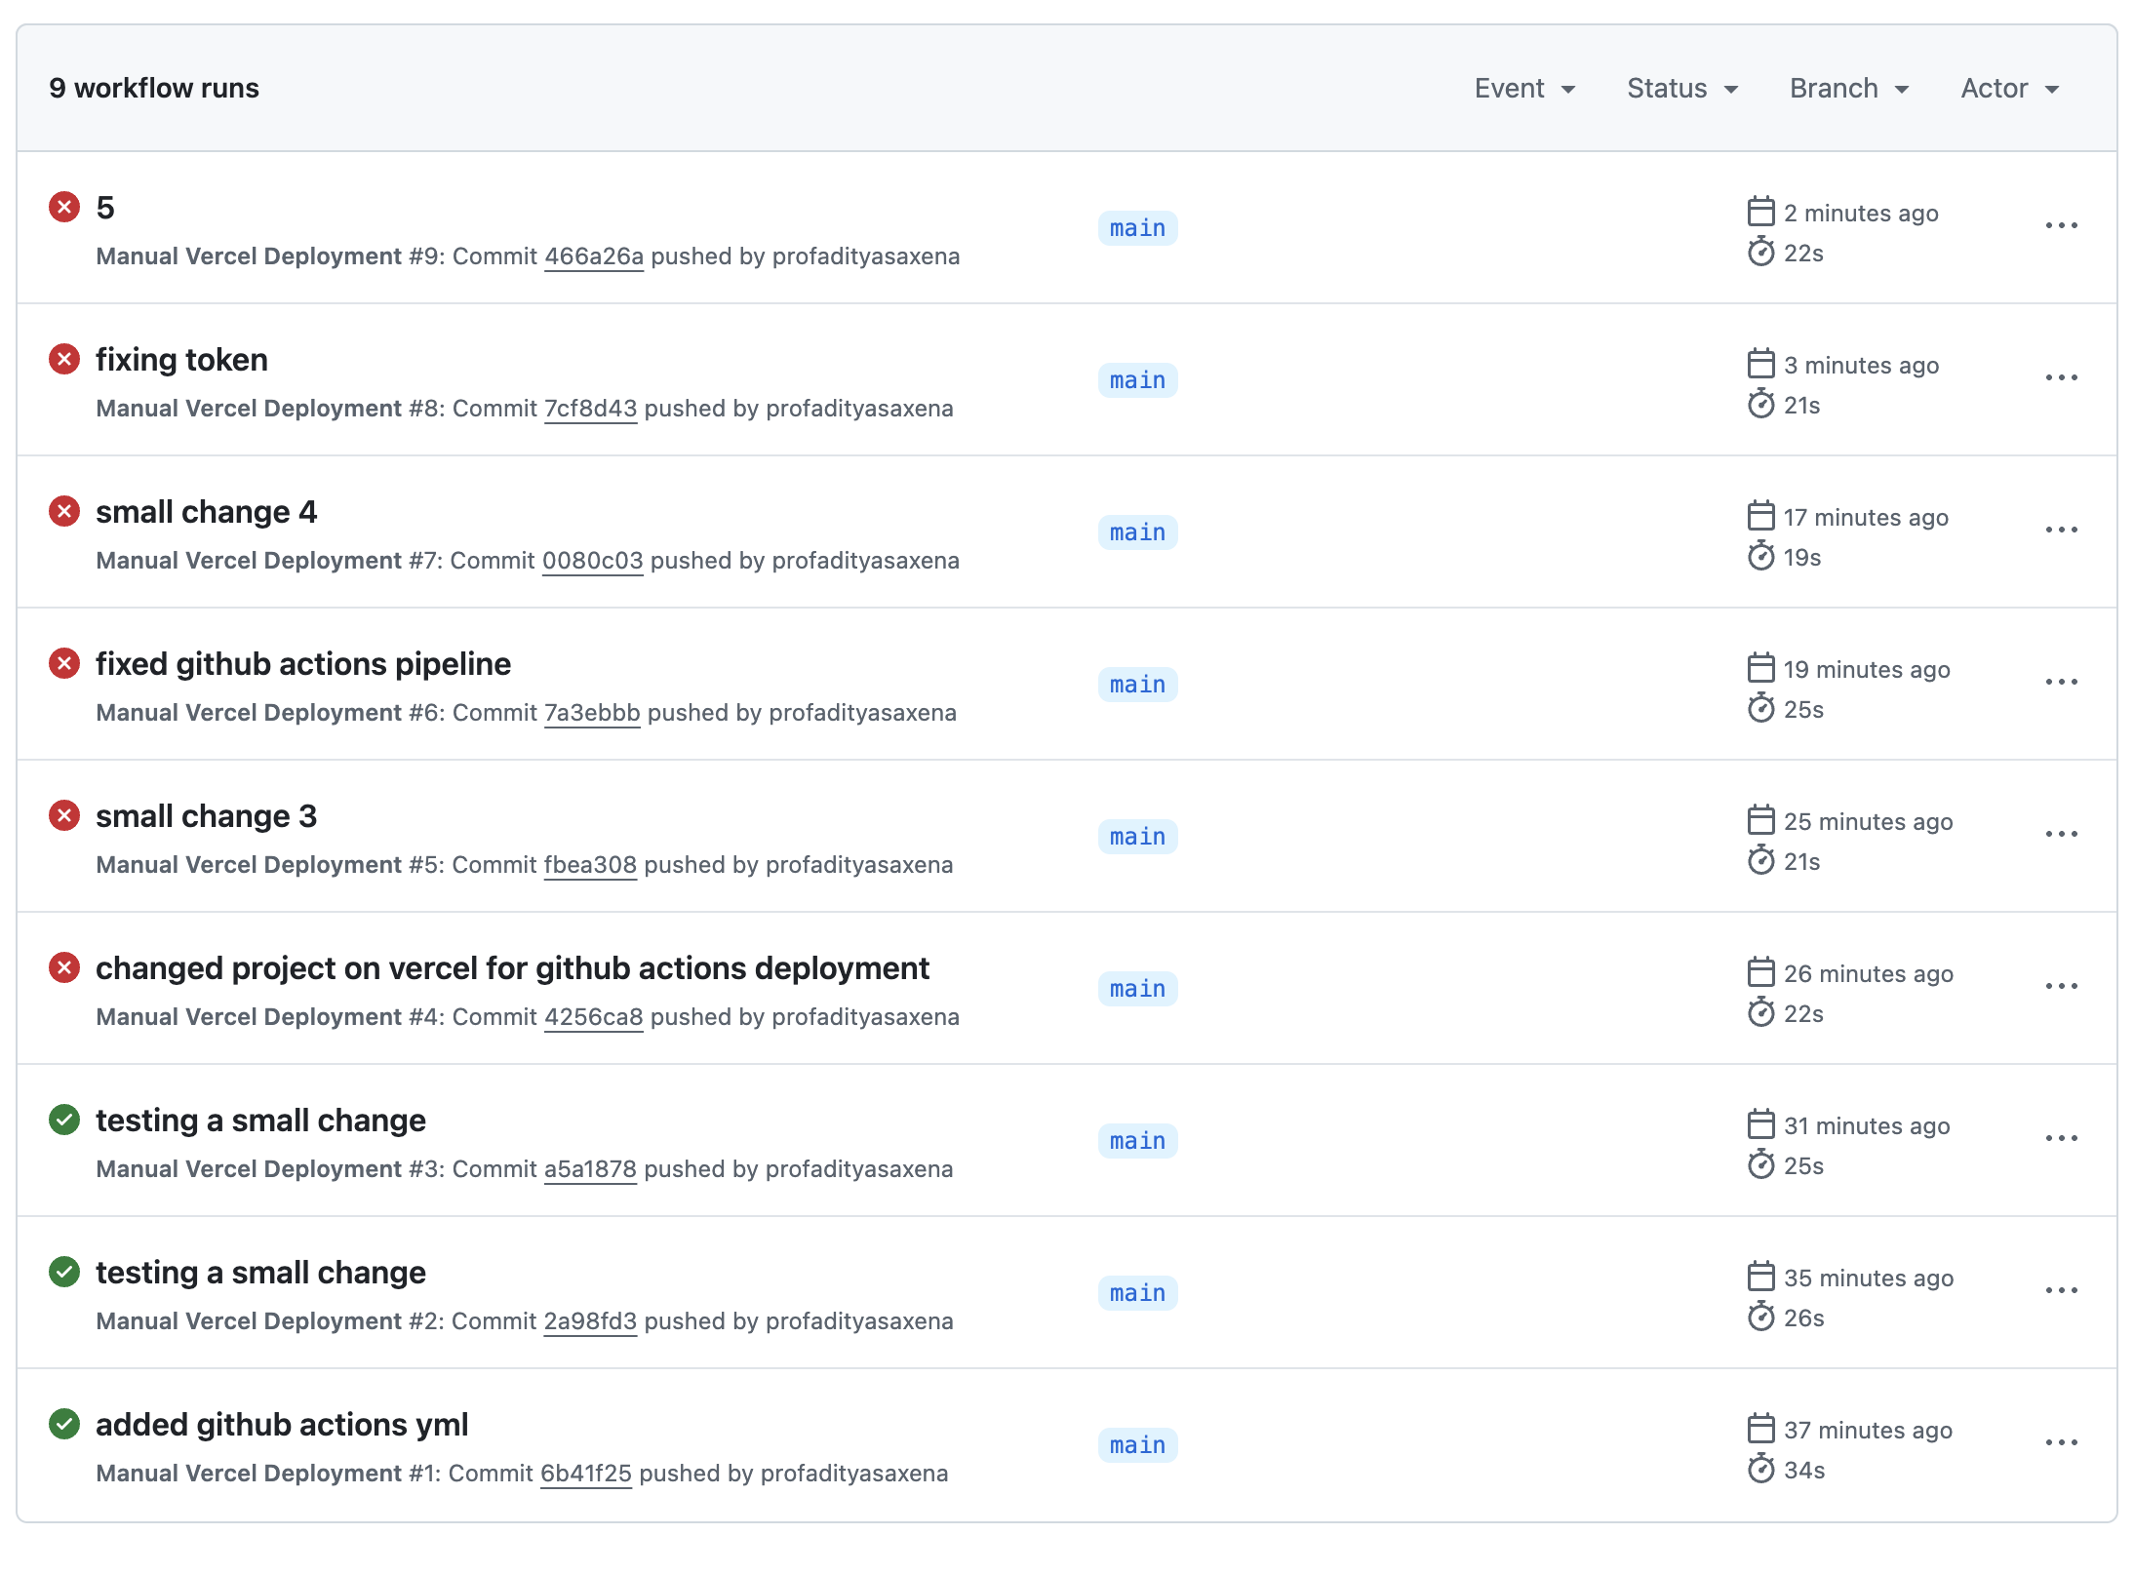

In this step, titled "Troubleshooting", we perform or document a key part of the GitHub Actions and Vercel deployment process. This may involve configuring the folder structure, setting up secrets, correcting workflow issues, or validating deployments. Screenshots help trace these events with visual context and confirm implementation accuracy.

# Step 6.2: Troubleshooting

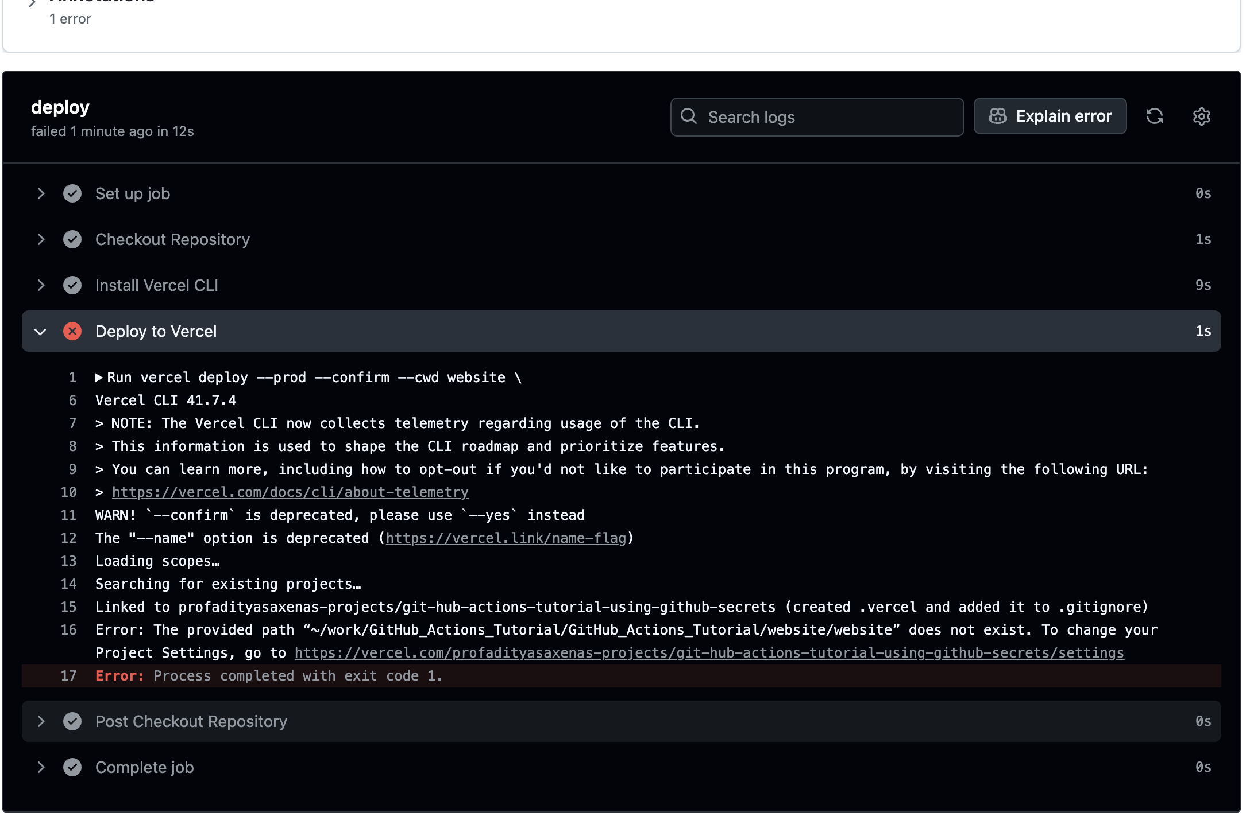

In this step, titled "Troubleshooting", we perform or document a key part of the GitHub Actions and Vercel deployment process. This may involve configuring the folder structure, setting up secrets, correcting workflow issues, or validating deployments. Screenshots help trace these events with visual context and confirm implementation accuracy.

# Step 6.3: Troubleshooting

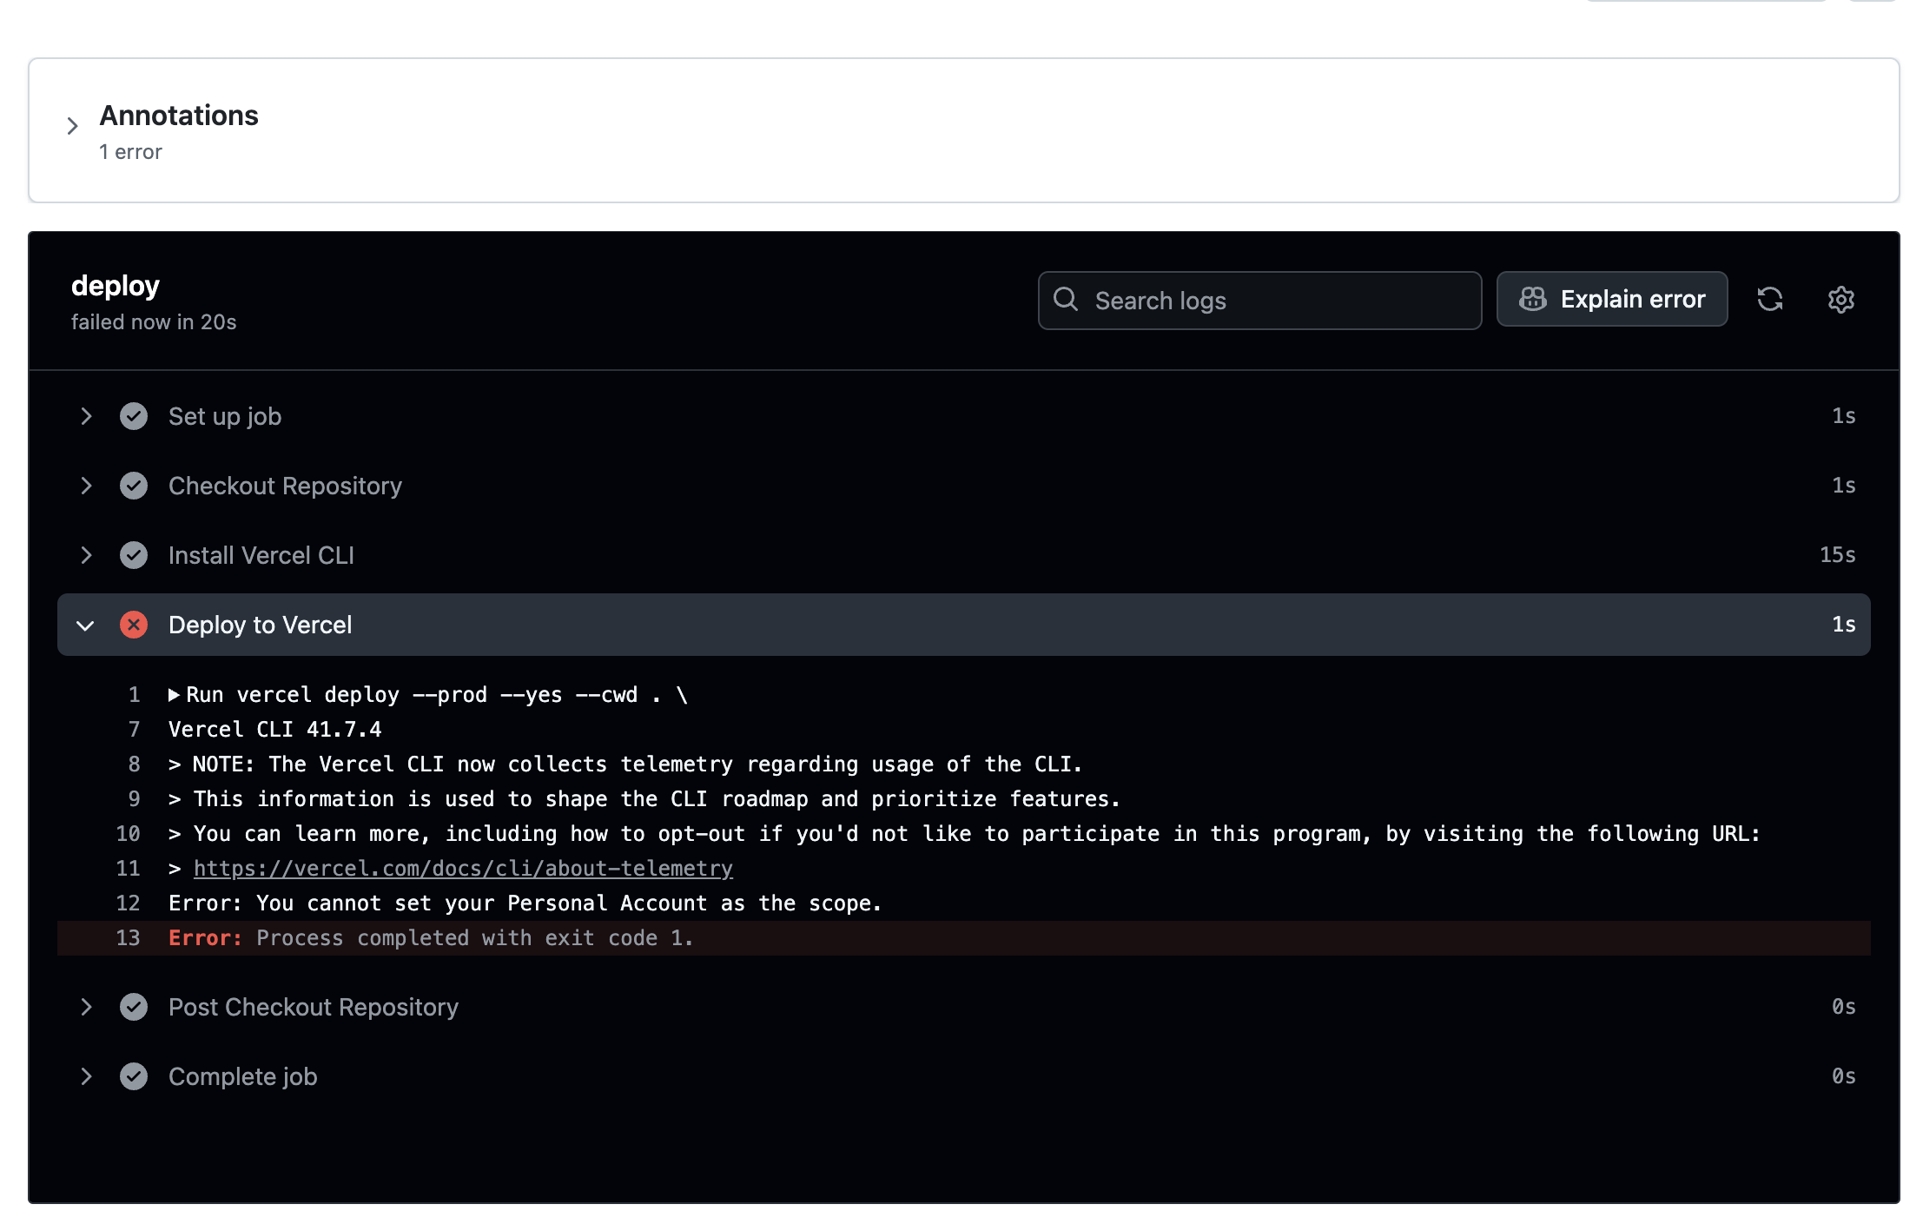

In this step, titled "Troubleshooting", we perform or document a key part of the GitHub Actions and Vercel deployment process. This may involve configuring the folder structure, setting up secrets, correcting workflow issues, or validating deployments. Screenshots help trace these events with visual context and confirm implementation accuracy.

# Step 7.1: Success

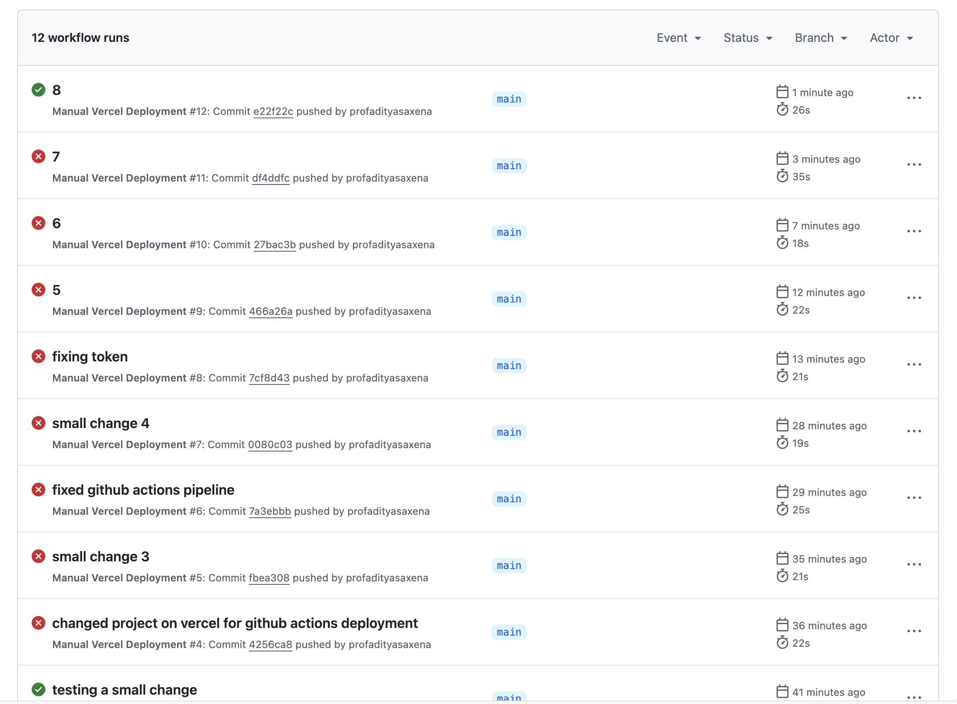

In this step, titled "Success", we perform or document a key part of the GitHub Actions and Vercel deployment process. This may involve configuring the folder structure, setting up secrets, correcting workflow issues, or validating deployments. Screenshots help trace these events with visual context and confirm implementation accuracy.